**EXPERIENCE LETTER**

<<LWD dd/MM/YYYY>>

**TO WHOMSOEVER IT MAY CONCERN**

This is to certify that **Mr/Ms. <<Full Name>>** was in the employment of our organization and his/her employment particulars are mentioned below:

Name: **<<Full Name>>**

Employee ID: **<<Emp ID >>**

Designation: **<<Designation >>**

Date of Joining: **<<DOJ dd/MM/YYYY>>**

Last Working Date: **<<LWD dd/MM/YYYY>>**

CTC: **$ <<CTC>>/-** (USD <<CTC in words>> only)

We wish **<<First Name>>** all the best in his/her future endeavors.

Yours Sincerely,

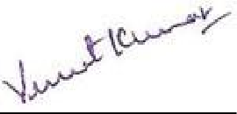

Vineet Kumar

Co-Founder, CEO-US

Affine Inc.

**Affine Inc.**

2018,156th Avenue, NE Building F, Suite #306, Bellevue, WA 98007

Tel: +91-80-6569-0996 | Web: affine.ai | Mail: [info@affine.ai](mailto:info@affine.ai) Affine Confidential

